Risk Prediction Model API Prototype

Step 1

Input URL:  [*http://ec2-54-67-99-52.us-west-1.compute.amazonaws.com:808*](http://ec2-54-67-99-52.us-west-1.compute.amazonaws.com:8081)*1* to load the Risk Prediction Model API Prototype Page.

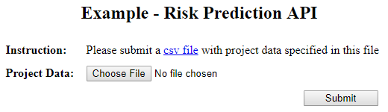

Step 2

Upload a csv file including the data according to the defined factors, which can also be downloaded from the link given in the above figure.



Step 3

View the risk prediction results given by the model.

